2023 Klein JV Volleyball Tournament

 | Pool 1 | Pool 2 | Pool 3 | Pool 4
 | Ct 1 (Main) | Ct 2 (Main) | Ct 3 (Aux) | Ct 4 (Aux)
1 | Grand Oaks | The Woodlands | Oak Ridge | Summer Creek JV | 1
2 | Klein Cain | Atascocita | Klein | Grand Oaks Flex | 2
3 | St. John’s | Klein Collins | North Shore | Klein Oak | 3
4 | Aldine | Klein Forest | Summer Creek 9 | Spring | 4

Pool Play Schedule (9/14/2023)
Start Time | Home Team | Away Team | Reffing Team
2:00pm | 1 | 3 | 2
3:00pm | 2 | 4 | 1
4:00pm | 1 | 4 | 3
5:00pm | 2 | 3 | 1
6:00pm | 3 | 4 | 2
7:00pm | 1 | 2 | 4

2023 Klein JV Tournament Bracket
Winner’s Bracket
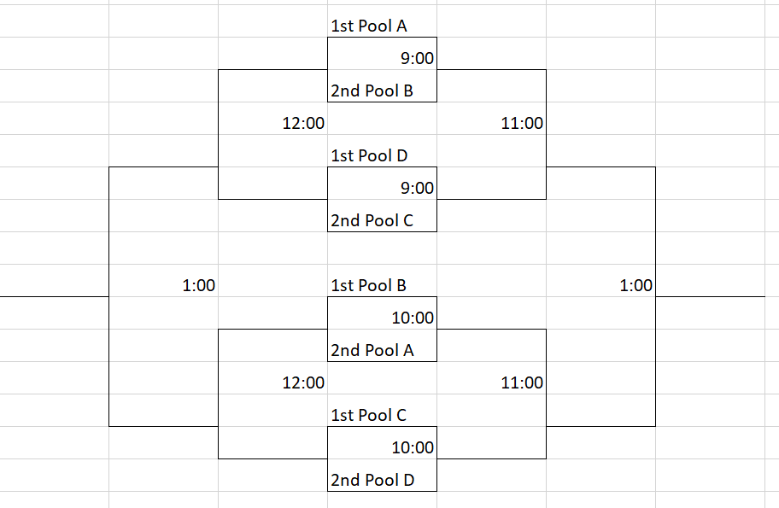
Consolation Bracket
